**Nama : Imbar**

**Kelas : FSWD3**

**Github**

**Link Github :** <https://github.com/ImbarInformatika/ImbarP10>

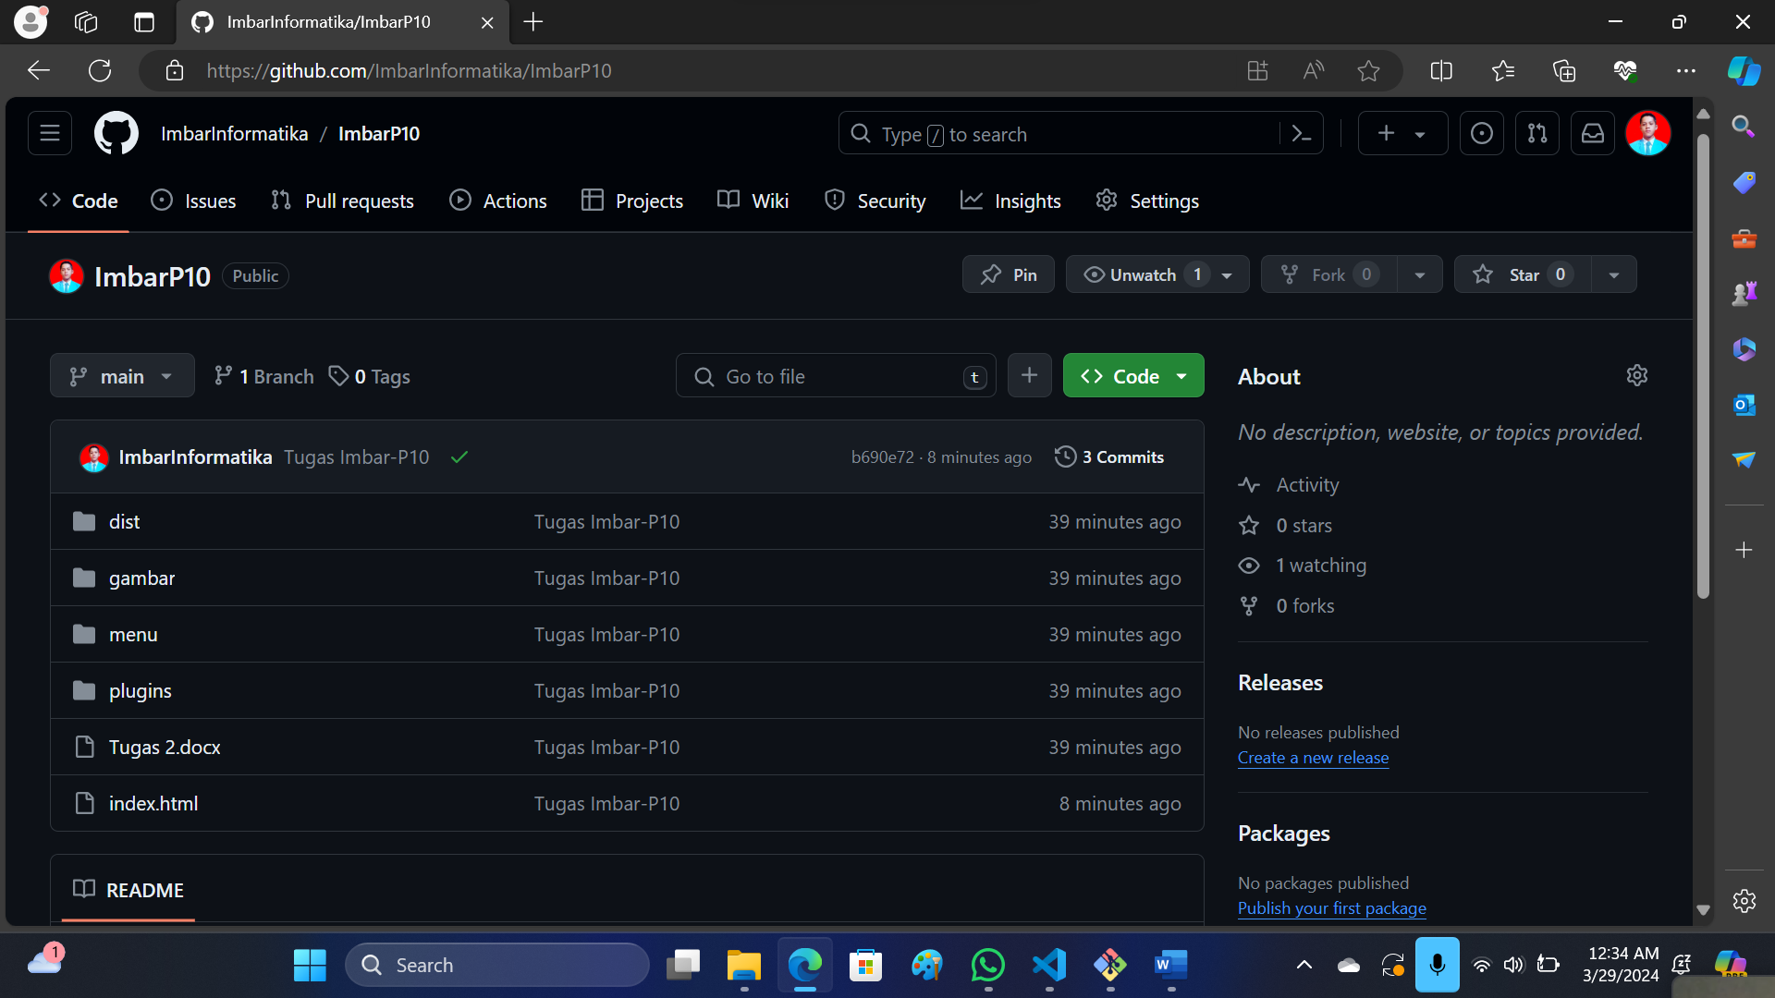

**Tampilan Githubpage**

**Halaman Dashboard :** <https://imbarinformatika.github.io/ImbarP10/index.html>

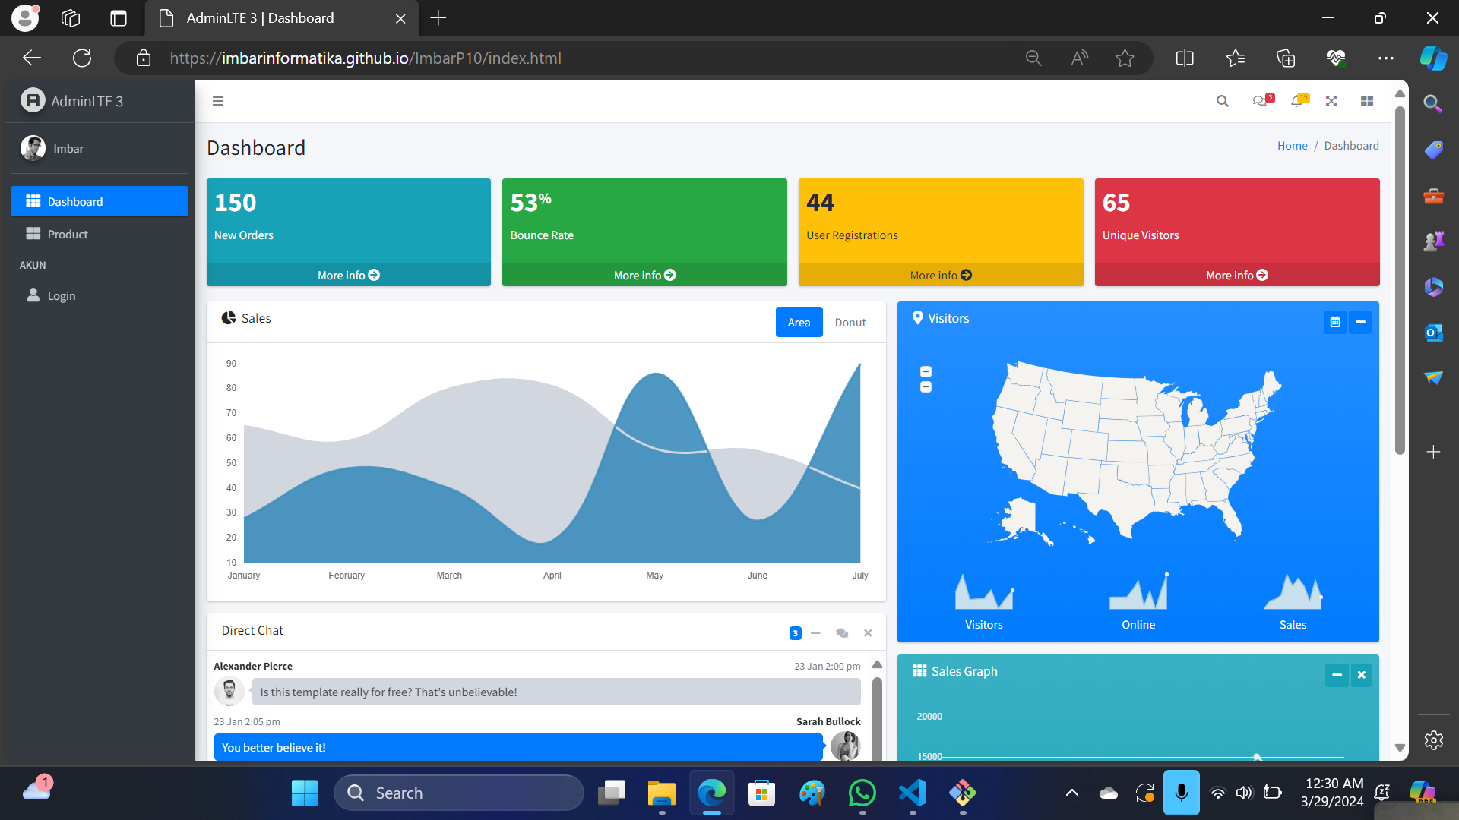

**Halaman Product :** <https://imbarinformatika.github.io/ImbarP10/menu/product.html>

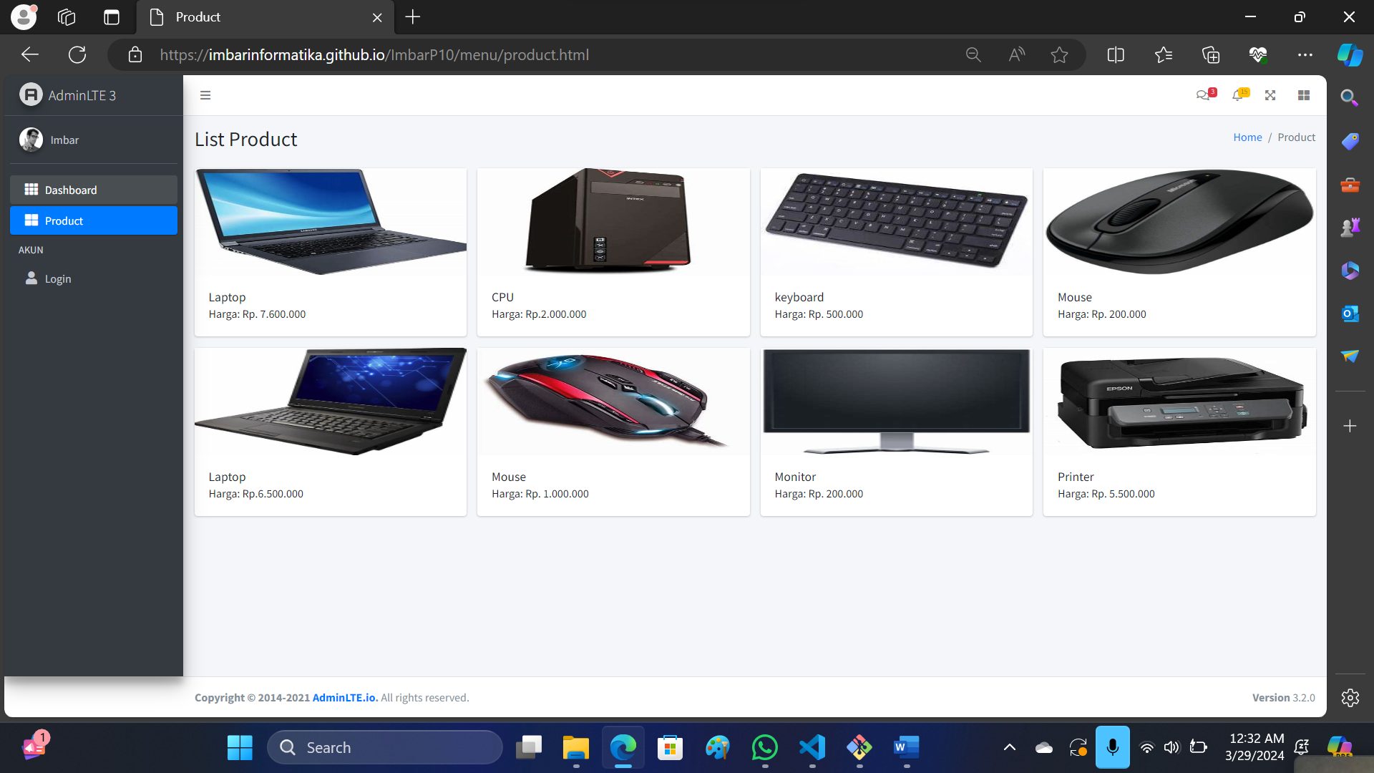

**Halaman Login :** <https://imbarinformatika.github.io/ImbarP10/menu/login.html>

